LeeWayne Barrineau

Chapter 4 Wild Wood Apt project

1. The following are requirements and business rules for the Wild Wood Apartment database
   1. Apartment managers must generate a quarterly report each quarter.
   2. Quarterly report should summarized the occupancy rate, total revenue in rent, total expenses, total profit, or loss and so forth for that apartment complex.
   3. Apartment managers must enter lease information, rent payment information and maintenance information.
   4. There is a grace period for tenants to pay their rent after the due date for rent.
   5. Currently the grace period is five days after the rent due date.
   6. After the grace period is up a penalty fee is add to the rent, if the tenant has not paid yet.
   7. Currently the penalty fee set by Wild Wood Apartment headquarters is 100 dollars.
   8. Wild Wood Apartments headquarters needs to see all the information inside the database
   9. An override system needs to implement since some tenants have more leeway with the grace period.
   10. Apartment managers should only see their part of the database and not another manager’s sector.
2. Below are the entities, their attributes, and the relationship between the entities.
   1. Headquarter manager
      1. First name
      2. Last name
      3. Phone number
      4. Position
      5. Manager ID
   2. Apartment manger
      1. Apartment complex name
      2. Apartment complex location
      3. First name
      4. Last name
      5. Apartment number
      6. Phone number
      7. Apartment Manager ID
   3. Lease information
      1. Lease number
      2. Lessee name
      3. Amount paid
      4. Deposit
      5. Start date
      6. End date
   4. Maintenance information
      1. Apartment number
      2. Start date
      3. Problem
      4. Type of the problem
      5. Resolution / solution
      6. Resolution date
      7. Expense
   5. Payment information
      1. Date payed
      2. Tenant’s name
      3. Apartment number
      4. Leased number
      5. Amount paid
      6. If it was late or not
   6. Quarterly report
      1. Location
      2. Quarter
      3. Current year
      4. Total amount of apartments
      5. Total occupied apartments
      6. Occupancy percent
      7. Total revenue in rent
      8. Maintenance expenses
      9. Unpaid rent amount
      10. Total profit or lost amount
   7. Apartment
      1. Tenant
      2. Lease Number
      3. Apartment Number
      4. Apartment Manager
      5. Location
   8. Tenant
      1. Room Number
      2. Lease Number
      3. First Name
      4. Last Name
   9. Relationships
      1. The headquarter manager and the apartment manager entities would have a relationship of a many to many. This is because there are many headquarter mangers that can check on the apartment manager, thus creating the one side of the many to many. While at the same time multiple apartment manager can be connect to a single headquarter manager, thus creating the other side of the many to many.
      2. Apartment manager would have a one to many relationships with the quarterly report entity. This is a one to many because one apartment manager will make multiple quarterly reports
      3. Quarterly report entity would have a many to many relationships with the headquarter managers. Because there are multiple managers that need to see quarterly reports from all the apartment managers, thus making this type of relationship.
      4. The apartment manager entity would have another one to many relationships but with the maintenance information entity. This is a one to many because there are many instances that need maintenance in an apartment complex but there is only one apartment manager that oversees the apartment complex.
      5. The maintenance information entity and the apartment entity would have a many to many relationships because the same maintenance problem can exist in the multiple. While at the same time a single apartment can have multiple maintenance problems.
      6. There would be a one to many relationships between the apartment and the tenant entity because only one apartment can hold the tenant or the tenants that live there. This relationship could change depend on the input from Wild Wood Apartment headquarter, to determine if there any rules about the number of tenants in an apartment
      7. Lease information and the payment information would have a one to many relationships because multiple payments information entity could hold the same lease number.
      8. The relationship between the tenant and the payment info is a one to many because during the tenant time at the apartment complex there will be several payments from that one individual. Further discussion from the headquarter would be needed to determine if the multiple tenants of an apartment could use the same payment information.
      9. Another one to many relationships would be between the apartment manager entity and the payment info because the single apartment manager would need to check off the payments inside the apartment complex.
      10. The final relationship would be between the tenant and the lease information entities. Their relationship would be one to many with the one side being the lease information. This because there would only be a single lease at a time for at least one tenant. This could also change depending on if only one tenant can sign the lease.
3. Below is a diagram showing the relationship between the entities for the Wild Wood Apartments. There are linking tables to show the two one to many relationships of the many to many relationships.
   1. 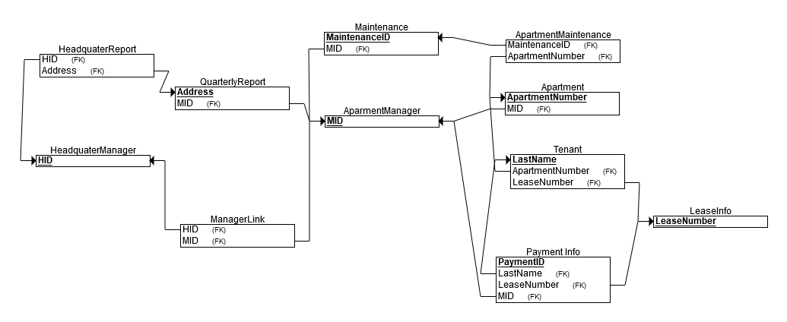
   2. The linking tables for the headquarter manager to apartment manager is the manager link table. The linking table for the quarterly reports to the headquarter manager is headquarter report. Finally, the apartment to maintenance linking table is apartment maintenance.
   3. Other connections between the rest of the entities were said in the relationship part of part 2.
4. Below is the same diagram from the Wild Wood Apartment database but it included the entities attributes and small updates on entity name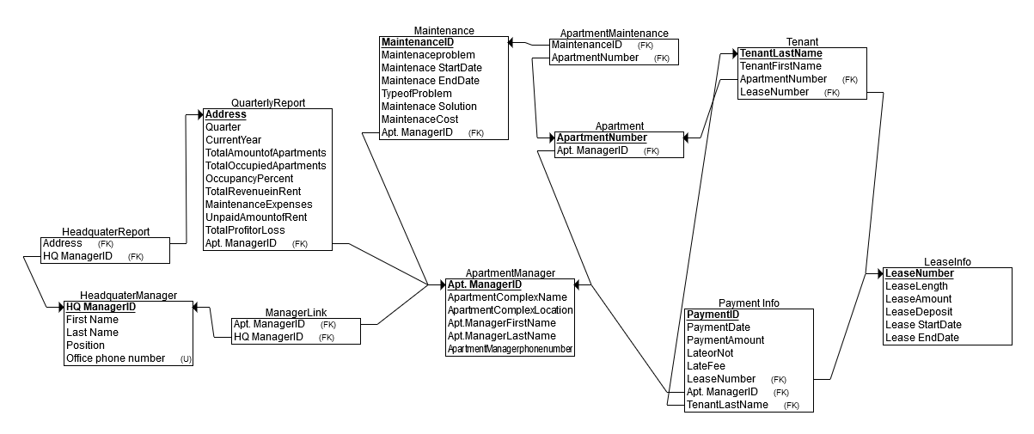
   1. The linking tables for the headquarter manager to apartment manager is the manager link table. The linking table for the quarterly reports to the headquarter manager is headquarter report. Finally, the apartment to maintenance linking table is apartment maintenance.
   2. Other connections between the rest of the entities were said in the relationship part of part 2.
5. Below is the primary key field and foreign keys in the entity for the Wild Wood Apartment database.
   1. Headquarter Manager entity
      1. The primary key or field for the Headquarter Manager entity is the HQ Manager ID.
      2. There are no foreign keys because the headquarter manager only has many to many relationships that are linked by the apportioned linking table
   2. Head Quarter Report entity
      1. Head Quarter Report entity is a linking table for the head quarter entity and the quarterly report entity, so there is no primary key for it.
      2. The foreign keys inside this linking table are the Address field from the quarterly report entity and the HQ manager id from the Headquarter manager.
   3. Quarterly Report entity
      1. The primary key or field for the Quarterly Report entity is the address since each apartment complex has a unique address.
      2. The is one foreign key or field which is the Apt. Manager ID since each apartment manager since the quarterly report needs to sign off on the quarterly report.
   4. Apartment Manager entity
      1. The primary key or field for the Apartment Manager entity is the Apt. Manager ID.
      2. There are no foreign key or fields inside this entity, but the Apt. Manager ID field is a foreign key in other entity.
   5. Apartment entity
      1. The primary key or field for the apartment entity is the Apartment Number field this is the key since there are no duplicates apartment number in an apartment complex. Thus, making it a unique number.
      2. There is a single foreign field, which is the Apt. Manager ID field this is the primary key of the Apartment Manager entity.
   6. Apartment Maintenance entity
      1. The Apartment Maintenance entity is a linking table for the head quarter entity and the quarterly report entity, so there is no primary key for it.
      2. The foreign keys inside this linking table are the apartment number field from the apartment entity and the maintenance id from maintenance entity.
   7. Maintenance entity
      1. The primary field for the maintenance entity is the maintenance id.
      2. The only foreign field is the Apt. Manager ID which is used to link to the Apartment Manager entity to the maintenance entity. Though the maintenance entity is also linked to the Apartment Maintenance entity.
   8. Tenant entity
      1. The primary key of the tenant entity is the tenant last name field.
      2. There are two foreign keys the Apartment number and the lease Number. The apartment number comes from the apartment entity while the lease number comes from the lease info entity.
   9. Lease Info entity
      1. The primary key of the lease info entity is the lease number.
      2. There is no foreign key inside the lease info entity since the primary key is sent out to make the relationship connections.
   10. Payment Info entity
       1. The primary field for the payment info entity is the payment id.
       2. There are three foreign keys inside the payment info entity, these being the lease number, apt. managers id and the tenant last name fields.
6. The following are the roles which each entity plays in the Wild Wood Apartments Database.
   1. The entity which have the domain roles are the head quarter manger, apartment manager, maintenance, apartment, tenant, lease info, payment info and the quarterly report entity.
   2. There are three linking entity which are the head quarter report, manager link and apartment maintenance entities.
7. Jason Lavoie check reviewed my work and said it looked fine but there might be more there than necessary at this point